 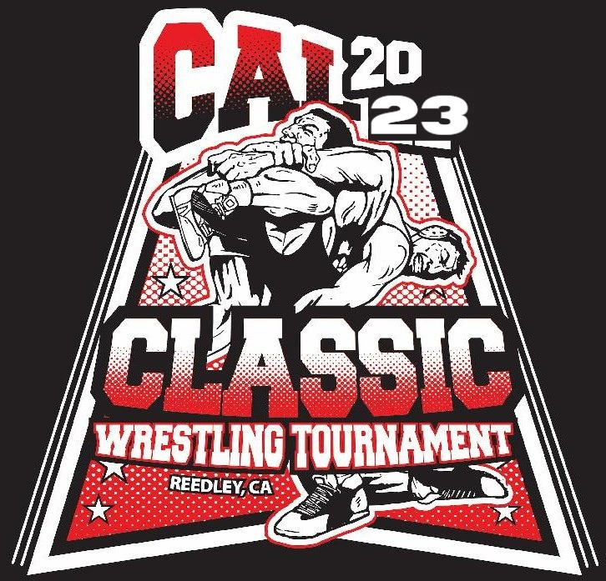

**First Annual- Girls CAL Classic**

**at Reedley High School- No Boys Allowed**

**2023**

**When:** Varsity - Friday, December 8, 2023

**Time:** Weigh-ins at 10:00am, Wrestling starts at 12:00pm

**Where:** Reedley High School

740 North Ave., Reedley, CA. 93654

**Cost:** $200 (14 wrestlers) due by day of tournament

$35 per wrestler for teams of 6 wrestlers or less.

**Teams:** Limited to the First 24 teams to turn in their contract. You can weigh-in more than 1 wrestler per weight. Only one wrestler will count towards team score.

**Weights: 101, 106, 111, 116, 121, 126, 131, 137, 143, 150, 160, 170, 189, 235**

**plus 2 pound allowance**

**Format:** 16-Wrestler Bracket – To avoid 6 match rule if necessary.

* + - Each bracket will wrestle to 5th place
    - Consolation can only wrestle to 5th place.
    - Semi-Final loss will wrestle for 3rd and 4th.

**Awards:** Top 4 Medal and Top Three Teams

**Coaches:** 2 Coaches bands hospitality lunch

**Seeding:** Seeding will be done online with more information to follow.

Tournament Director: Pablo Saenz 559-356-9814 [saenz-p@kcusd.com](mailto:saenz-p@kcusd.com)

**“Girls Cal Classic”**

# Friday, December 8, 2023

**School: _____________________________________________________________________________**

**School Phone Number: _____________________ Coach’s Cell: _____________________________**

**School Address: ______________________________________________________________________**

**School Fax:**

**AD’s Name: AD’s Email:**

**Coach’s Name: Coach’s Email: **

The above-signed High School agrees to compete in the Lady Pirate Battle for The Ship on December 1, 2023. The tournament entry fee will be $200.00 per team or $35 per individual wrestler and must be paid by day of tournament, after which there will be a $50 late fee. The tournament will be a 16-wrestler bracket. Your tournament confirmation letter will be emailed to the Head Coach upon acceptance of this Contract.

Yours in Wrestling,

Pablo Saenz

Tournament Director

*Signing this contract means the participating school will be responsible for paying the entry fee to attend the tournament even if the school is unable to attend. No refunds will be given. Please sign the approval of this agreement on the appropriate line below.

Athletic Director Signature: _____________________________________ Date: _______________

Coach Signature: _____________________________________________ Date: _______________

Please make checks payable to “**Reedley High Wrestling**” and mail contract(s) to:

Reedley Wrestling

Attn: Pablo Saenz

740 W. North Ave. Email Contract to: [saenz-p@kcusd.com](mailto:saenz-p@kcusd.com)

Reedley, Ca. 93654 AD: [minami-d@kcusd.com](mailto:minami-d@kcusd.com)