Tokay’s “Goddess of War” JV and Varsity Tournament

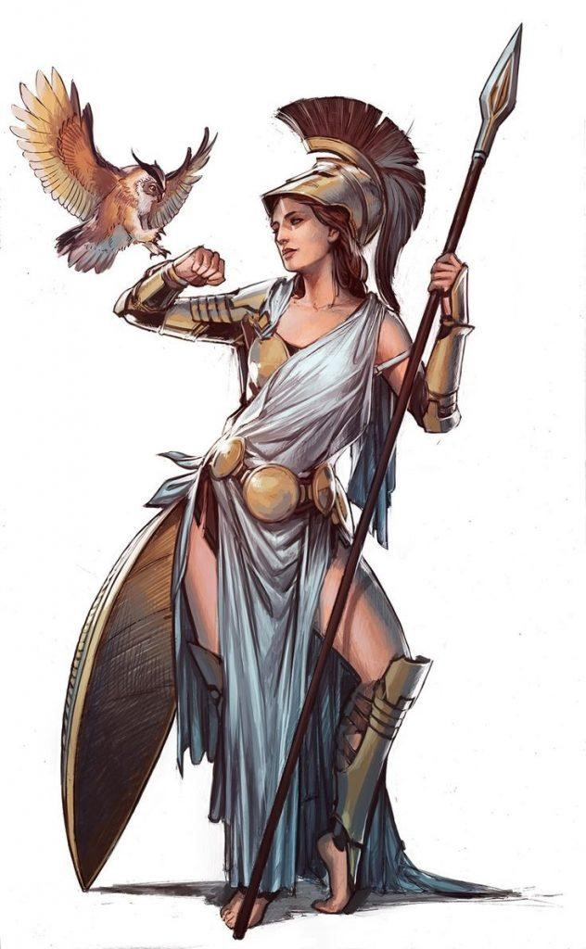Coaches, we would like to invite you and your team to the 2nd Annual “Goddess of War” JV and Varsity girls wrestling tournament, hosted by the Tokay girls wrestling team. Our hope is to provide our girls with ample mat time and offer high-level competition for experience girls. Space will be limited, so please message me if you’re interested, please contact me to hold your spot ASAP.

**Date:**11/25/2023 **Location:** Tokay High School, 1111 W Century Blvd Lodi, CA 95242

**Girls:** JV (Round Robin)/ Varsity Tournament

**Doors open:** 5:30 am

**Weigh-Ins:** 7:00-8:00 am **Wrestling begins:** 9:00 am in 2 GYMs on 7/8 mats

**Eligibility:** Any female wrestler in good standing with her high school in accordance with CIF rules

**Varsity Weight Classes**: To be announced.

**Varsity: 16-man bracket (Double Elimination**) Medals awarded to Top 4, placers.

**JV: Pulled weight (Round Robin)** Medal Top 3, placers.

**Style: Folk-style**

**Trainer**: Available at the tournament

**Registration**: Entry Fee is $40 per wrestler, $400 per team (10-14 wrestlers) and $25 for each additional wrestler. Register your team by Monday 11/21/23 by 8 pm. Email me ASAP to reserve your team’s spot, limited room is available. Team registration info will be emailed out to the confirmed team prior to the tournament. We will be running the Varsity tournament on TRACKWRESTLING, JV will be ran by hand. You can send check or pay at the door.

**Make checks payable to: “TOKAY WRESTLING BOOSTERS”** Send to: C/O George Bozovich: 1966 Yorktown DR Lodi, CA 95242. Checks need to be received by mail Nov 3rd or payment received at check-in.

For additional information contact, George Bozovich 209-242-3090 Email: tokaygirlswrestling@gmail.com